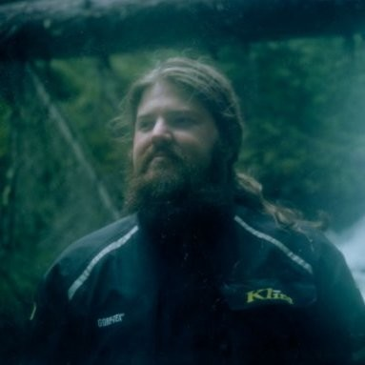
Nathan Slabaugh
Nathan Slabaugh grew up in the farming community of Sandusky Michigan. He holds degrees in Music Education and Musical Performance from Temple University in Philadelphia. After graduating, he played trumpet professionally across the U.S. for 6 years with Ringling Brothers and Barnum and Bailey circus and then settled in the beautiful Pacific Northwest. After launching his photography and videography career in 2008, he spent years capturing the work of Fuller Center for Housing, The Specialty Coffee Association, and other large organizations. While working with the team at Silverwood Theme Park, he met his now wife Angela Slabaugh. In 2017, Nathan focused full-time on his freelance filmmaking and photography and enjoys sharing the power of story through these mediums.
Filming the IOIA/NOP project was an immense pleasure, bringing Nathan in close contact with his farming roots and stoking his passion for sharing the powerful work and story of organic farming and the inspectors that play an integral role in this field.

