2023 Board of Director Candidate Statements
Questions forwarded to Candidates by the Membership Committee:
- How many inspections did you do in 2022?
- What do you see as the most important goals for IOIA in the next year?
- The next five years?
- If you work for a certifier in a capacity other than an independent contractor, please explain.
- Mention any involvement in IOIA as a trainer or on committees.

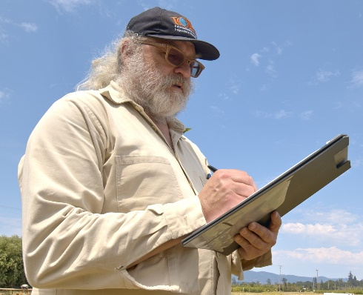
Brian Baker, Oregon, USA
- In the 2022 season I conducted 8 organic inspections in three scopes.
- The most important goals for IOIA in the next three years are to:
- Prepare training materials to build capacity in the organic sector.
- Protect and empower organic inspectors in the context of anticipated regulations.
- Train inspectors in underserved scopes, particularly input manufacturers.
- In the next five years, I see following goals as a priority for IOIA:
  - Fiscal stability and financial security.
  - Respectful and competent leadership transition.
  - Fair employee / contractor – employer / contractee relations with Certification Bodies.
- In 2022, all my work was as an independent contractor. I have not been on anyone’s payroll since 2013.
- I am an incumbent IOIA Board member. Prior to joining the IOIA Board, I conducted trainings for IOIA going back to 1994. I serve as Board contact on the Scholarship Committee.

The first organic inspection that I conducted was for NOFA-NY in 1986. In 1988, I was hired by CCOF as perhaps the first employee dedicated full-time to organic certification. In addition to inspecting crop, livestock, and handling operations, I trained and supervised all CCOF’s inspectors, and reviewed and approved all inspection reports that I did not write myself. I was a co-founder of OMRI and conducted the first input supplier inspections. I have served on the IFOAM Standards Committee and am familiar with international organic standards.
I would be honored to continue my service on the IOIA Board and ask for your vote.

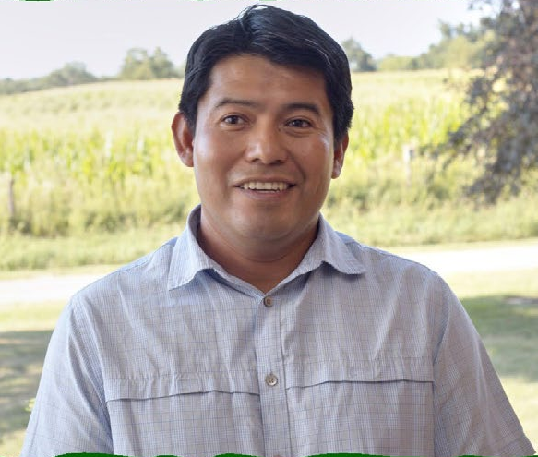
Margarito Cal, Illinois, USA
Greetings IOIA Members! My name is Margarito Cal, and I am happy to present myself as a candidate for the IOIA Board. I was born in a Mayan village in Southern Belize and have lived in Northern California and Illinois. I come from an agricultural background and have grown diverse food crops in Belize, California, and Illinois. I am currently a full-time contract inspector and have done OSP Reviews in the past. In 2022, I completed 175 Crop, Livestock and Handler inspections for 6 certifiers, and currently on the IOIA Scholarship Committee. As an 8-year member of IOIA, I would like to commend the organization on its integrity and amplification of the inspector community’s voice.
Over the next year, I would like to see continued collaboration with the ACA on interpretation of new regulations (SOE & OLPS) and practical implementation of the new rules.
Over the next 5 years I would like to see continued engagement with the NOP regarding regulatory changes. I believe that the inspector community’s observations and experiences provide valuable key indicators about the effectiveness of current regulations and best practices. I would also like to see diversification of the inspector pool while extending efforts to include the international inspector community.
Thank you for your consideration.

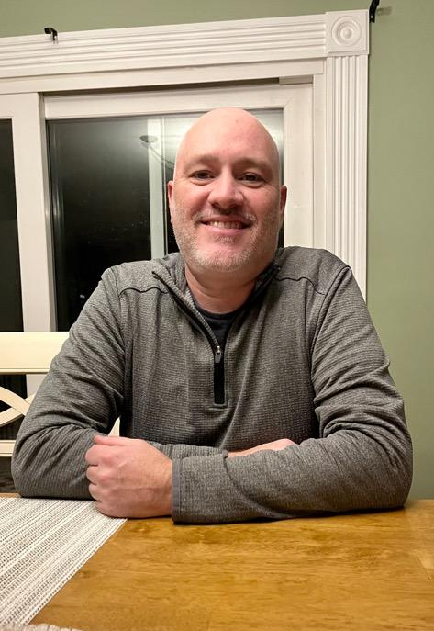
Darren Maum, New York, USA
I did approximately 160 inspections in 2022, both on site and virtually, for two different agencies. That number has been fairly consistent for the past 10 years. Scope of inspections range from small family farms to large international processors. In the past I have also done contract review work. I currently own a certified organic seed garlic farm in the fingerlakes region of upstate NY. I enjoy being able to take a break occasionally from the paperwork and traveling and get my hands back in the dirt.
My short term goal for IOIA is to build a robust field training and/or apprenticeship component to the training of new inspectors. New inspectors just out of the basic trainings are generally not sufficiently prepared to enter the field and perform inspections. I don’t think as an industry we can continue to rely on working inspectors to complete their training via informal mentoring. It is a great opportunity for IOIA to fill this role.
Long term goals for IOIA are:
- To continue to expand internationally.
- To continue to find ways, beyond training, that IOIA can help develop organic inspecting into a sustainable, professional career path; and support working inspectors.

As an IOIA inspector member since 2011 I have attended several advanced trainings/AGMs and participated in the Inspector Retention Working Group this past year.

Thank you.

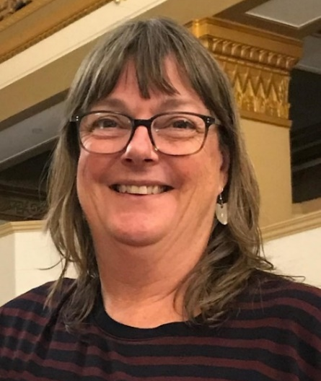
Kathleen (Kathe) Purvis, Western Australia, AUSTRALIA
Australian-based trainer, facilitator and auditor.
Former farmer, now growing own food in a sustainable urban farming system.
A lifetime of practice in organic and sustainable farming and nature regeneration.
More than 30 years auditing and training within Australia and internationally to organic and Fairtrade standards.
In 2022, to date, I have completed ~200 inspections including organic (50%), food safety, environmental and ethical audits.
As a representative for IOIA APC (Asia Pacific Committee) I see as the most important goals for IOIA in the next year to be the continued support for and engagement with international inspectors, and to provide training opportunities for both new and for senior inspectors.
In the next five years I would like to see IOIA expand connections with aligned environmental and ethical standards and inspectors working in these areas.
I complete training events and internal audits for Certifying bodies on request.
I have worked in the past as an IOIA trainer and am currently engaged in training development and other initiatives with IOIA APC.
APSCA accredited auditor for Ethical and Regenerative Organic programs
Diploma - Training Design, Development & Delivery
Bachelor of Sociology /Philosophy
Accurate & current to 27/11/2022

PJ Wiebusch, Washington, USA
I conducted my first Organic inspections in the Spring of 2017 and since that time have conducted over 700 inspections to the National Organic Program standard. Currently based out of Olympia Washington, I’ve worked for 3 different certifiers as a contract inspector and have done inspections all throughout the Western United states and as far south as central Mexico. In 2022 I conducted 140 inspections in 8 states to NOP crop, livestock, and handling scopes. This year I was also fortunate enough to participate in an IOIA Basic Crop Training as a group leader on the field trip and as a report-reviewer for several students in the course.
My on-job experience in a wide range of roles on diverse Organic farms coupled with my formal education in mathematics left me well positioned to feel comfortable and confident in my role as inspector both in the field and in the office.
IOIA provides fantastic basic inspection courses for new inspectors as well as advanced courses for continuing education but there is a major support void for new entrants into our line of work. At present, there are few paths to formal apprenticeship as an Organic inspector. I envision IOIA becoming a central clearinghouse for the inspector apprenticeship process.
IOIA is uniquely fit to advocate for inspectors where it is needed, gathering all of our input and acting as a megaphone for our many individual voices to be heard in unison. Over the next 5 years I hope to help bring the voice of new/young inspectors and help position IOIA to be the torch bearer for the future of the inspection industry.

