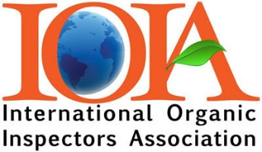

IOIA Self-Directed Learning Program
Application for Approval

Acceptance into this 200 Level course requires pre-approval before you pay or register for the course.

Please complete the following questions and email to: ioiaonlinetraining@ioia.net

IOIA SDL staff will review your level of training and experience to determine qualifications for the 200 Level American Grassfed course.

- Are you an IOIA Member? Yes No

Name:
Email:
Telephone:

- Are you currently an Organic:

Inspector Yes No Number of years Number of inspections
Scopes
Reviewer Yes No Number of years Number of reviews
Scopes
Program manager? Yes No Number of years
Scopes

- Have you completed the Basic IOIA Livestock Inspection course? Yes No
- IOIA 100 Level Livestock Standards Webinar? Yes No
- IOIA Field Training? Yes No

If no to the previous IOIA training questions, please explain why you feel you are qualified to take this course.

