2023 Advanced Training Speaker Bios

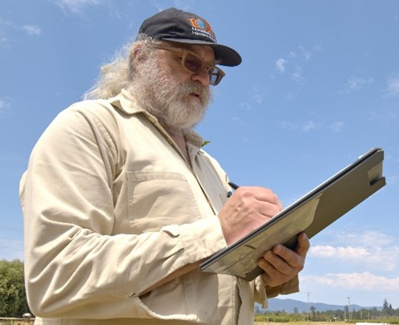
Dr. Brian Baker has worked in organic agriculture since 1983. Brian grew up on a small family farm in Western New York, He received his Ph.D. in Agricultural Economics from Cornell University in 1985. At Cornell, he was a member of the Ecological Agriculture Research Collective. Baker performed his first organic farm inspection for NOFA-NY in 1986. Following the award of his doctorate, Baker was a post-doctoral fellow at the University of California, Berkeley. In 1988, Baker left academia to work as the first full-time certification staff person at California Certified Organic Farmers (CCOF). There he conducted inspections and trained, managed, and reviewed the work of inspectors. From there he was a founder of the Organic Materials Review Institute (OMRI) and pioneered the inspection of input suppliers. Since leaving OMRI, Baker has divided his time between farming, teaching, inspecting, consulting, and research. Baker was the Director of Sustainability at Alfred State College (SUNY). He also served as International Research Networker at the Research Institute of Organic Agriculture (FiBL), where he helped to launch the Technology Innovation Platform of IFOAM. Currently, Dr. Baker serves as an affiliate faculty member of the Environmental Science Graduate Program at Oregon State University, maintains a research consulting practice in Eugene, Oregon, USA, and conducts inspections for several certifying agents and materials review organizations.

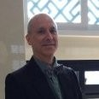
David Gould: “Sustainability is cross-cutting, regardless of sector. It requires a collective effort by people who want to be part of the solution. I have worked with the entire supply chain from seed to table, raw material to finished product, with producers, manufacturers, organizers, managers, government officials and agencies, certification bodies, accreditation bodies, inspectors, students, and professors. Better products, better environments, better empowerment of people, a better future - I use technical knowledge, clear vision and ideals, communication skills and tools, and interpersonal dynamics to help people make their and others' lives better.”
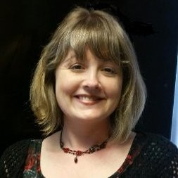
Heather Hawthorne, Inspections Supervisor, OMRI, holds a B.S. in General Science with minors in Biology and Chemistry from the University of Oregon. Prior to joining OMRI in 2017, she led quality assurance departments in the organic food manufacturing/ distribution companies and an herbal supplement manufacturer.

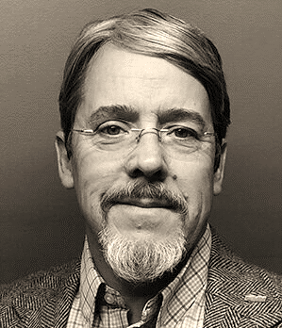
Garth Kahl has worked as an organic inspector for nearly 25 years, working on 3 continents, including inspections of crops, processing, wild harvest, livestock, apiculture, grower groups and textiles. He is accredited as an organic inspector in all scopes by the International Organic Inspectors Association. From 2007 to 2011 he was the Latin American Program Manager and interim Farm Program Manager for Oregon Tilth Certified Organic. Garth currently serves on the Mexican Materials Review Panel for OMRI and the Impartiality Committee for the International Organic Accreditation Agency (IOAS).

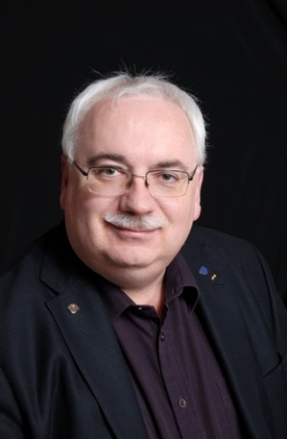
George Lewko PAg, has been a Professional Agrologist since 1994. He received his Bachelor of Science in Agriculture from the University of Saskatchewan College of Agriculture in 1992. (Major: Crop Science Minor: Horticulture). He completed his Forensic Agrology Certificate from the University of Saskatchewan in 2006. Southwest of Prince Albert, he operated his family grain farm until a combine accident in 1997. In 2013, Agro-tourism started with growing pumpkins and a haunted corn maze at his business, Paintball Paradise Prince Albert (started 1994). George has taught the Pesticide Applicator Course from SIAST/SK Polytech. He has settled many disputes in crop damage, spray drift, and herbicide efficacy.
George is a Past President of the Saskatchewan Institute of Agrologists 2005-2006. He has been the Past President of the Northeast Branch (formerly Melfort Branch) twice, 1998-1999, 2003-04. He has helped instruct the Institutes Professionalism and Ethics Seminar, since 2005-2011, which is a required course for all Articling Agrologists and Articling Agricultural Technologists. He has been on and chaired the Institute's Disciplinary Committee. Starting in 2020, George is an instructor for the SIA Forensic Agrology Course.
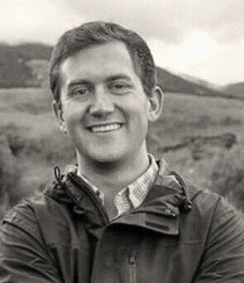
Nate Powell-Palm first started in the organic industry when he received certification for his diversified crops and livestock operation. Since 2012, Nate has worked as an organic inspector in 41 states including livestock, crops, and processing inspections. Nate has served as a consultant to companies throughout the organic supply chain from multinational companies to startup manufacturers. Nate has developed and lead trainings throughout the US and Asia. In 2019, he provided testimony regarding the economic opportunities for farmers through sustainable agriculture before the U.S. House of Representatives. Nate currently serves in the farmer seat on the National Organic Standards Board.

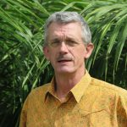
Bo Van Elzakker is director of the Agro Eco – Louis Bolk Institute, an independent advisory research development organization active mainly in West Africa. He has more than 30 years of experience in all aspects of organic agriculture: primary production, producer organization, access to inputs, value chain development, conversion & business planning, marketing, and ensuring organic integrity. He is chairman of the Accreditation Committee of ASI which is accrediting certification bodies to a variety of voluntary standards like MSC, FSC, ASC and RSPO. He is one of the initiators of the Anti-Fraud Initiative4, learning from past fraud cases, organizing multi-stakeholder workshops to improve the integrity of organic certification, and doing due diligence audits of certification bodies and for organic buyers.

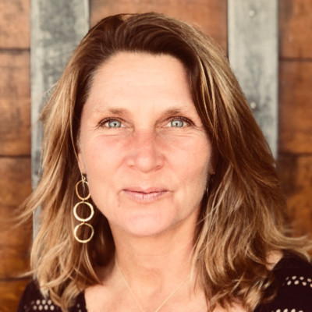
Elizabeth Whitlow has worked across the spectrum of elevated certifications both in farming and ranching for more than 20 years. She resides in Sonoma County, California.

